Chapter 8, Problem 42.

Given the network in Fig. 8.90, find v(t) for t > 0.

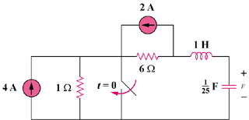

Figure 8.90
For Prob. 8.42.

